Medical Care Collections Fund (MCCF) eBilling

Electronic Data Interchange (EDI)

Transactions Applications Suite (TAS)

Interface Control Document

ASC X12N/005010 835 Medicare – Equivalent Remittance Advice (MRA)

Logo for the Department of Veterans Affairs, Office of Information and Technology, Product Development, including the official seal of the Department of Veterans Affairs


Department of Veterans Affairs

May 2018

Version 1.1

Revision History

|  |  |  |  |
| --- | --- | --- | --- |
| Date | Version | Description | Author |
| 05/02/2018 | 1 | Initial creation of document | Steffen Maerdian - Halfaker |
| 05/07/2018 | 1.1 | Added corrected 835 MRA JSON file | Steffen Maerdian - Halfaker |
|  |  |  |  |
|  |  |  |  |
|  |  |  |  |
|  |  |  |  |
|  |  |  |  |
|  |  |  |  |
|  |  |  |  |
|  |  |  |  |
|  |  |  |  |
|  |  |  |  |
|  |  |  |  |
|  |  |  |  |
|  |  |  |  |
|  |  |  |  |
|  |  |  |  |
|  |  |  |  |
|  |  |  |  |
|  |  |  |  |
|  |  |  |  |
|  |  |  |  |

Table of Contents

1 Introduction 1

1.1 Purpose 1

1.2 Scope 1

1.3 System Identification 1

1.3.1 MCCF EDI TAS eBilling 1

1.3.2 FSC 2

1.4 Operational Agreement 2

2 Interface Definition 2

2.1 System Overview 2

2.1.1 Overview Diagram 3

2.2 Interface Overview 5

2.2.1 Connectivity between the systems 5

2.3 Operations 5

2.3.1 Data Extraction 5

2.3.2 Data Transformation 6

2.3.3 Sending/Receiving 6

2.4 Data Transfer 6

2.5 Transaction Types 6

2.6 Data Exchanges 6

2.6.1 FHIR Based Resources 6

2.6.2 Bundle Definition 7

2.7 Communications Methods 10

2.7.1 Ports and Protocols 10

2.7.2 ESB Configuration(s) 10

2.7.3 System Configuration 10

2.8 Performance Requirements 10

2.9 Security 10

2.10 Testing Requirements 10

2.10.1 Comparison of Data 11

2.10.2 Completeness 11

2.10.3 Load Testing 11

2.11 Policies and Constraints 11

2.11.1 HIPAA Compliance 11

3 Appendix A 12

3.1 Data Elements 12

3.2 Bundle 12

3.2.1 MRA Bundle 12

3.3 Resource Sections 13

3.3.1 835 MRA FHIR Bundle Resources 13

3.4 Mapping Sheet 13

4 Appendix B - TASCore Mapping Rules 14

5 Appendix C – TASCore Default Values 14

6 Appendix D – FSC Mapping Rules 14

7 Appendix E – FSC Default Values 14

8 Glossary 14

9 Attachment A – Approval Signatures 15

Table of Figures

Figure 1 - Interim Solution 3

Figure 2 - To Be Solution 4

Figure 3 - Connectivity 5

Figure 4 - FHIR Bundle 8

Figure 5 - FHIR Bundle JSON 9

# Introduction

This document describes the interface between the MCCF EDI TAS eBilling application and the VA Financial Services Center in Austin, TX (FSC) for ASC X12N/005010 835 MRA messages.

## Purpose

The purpose of this Interface Control Document (ICD) is to define the message structure and protocols which govern the interchange of data between the FSC and eBilling within MCCF EDI TAS related to the electronic processing of ASC X12N/005010 835 MRA messages.

## Scope

This ICD specifies the interface between FSC and MCCF EDI TAS eBilling. This document provides details on the functional, performance, operational, and design requirements for the interface. This document defines the layouts for the data that the FSC sends to MCCF EDI TAS eBilling. This document is intended for all parties requiring such information, including business stakeholders, end-users, software developers, system designers, testers, and anyone else responsible for implementing this interface.

## System Identification

This ICD describes a generalized interface between the MCCDF EDI TAS Platform and the system(s) at the FSC.

### MCCF EDI TAS eBilling

The MCCF EDI TAS Platform will modernize and automate the business processes used currently as part of the VA revenue cycle. This includes insurance verification, billing and claims processing, payment, and remittance. These processes are tied to other processes that are out of scope, including documenting the care provided, coding treatment and encounters, and sending claims and receiving remittance to and from the Health Care Clearing House (HCCH).

This interface supports the electronic third-party billing process which involves the electronic transmission of 835 MRA messages between FSC and MCCF EDI TAS eBilling.

|  |  |
| --- | --- |
| System | Details |
| Title | tbd |
| Abbreviation | tbd |
| Version number | tbd |
| Release number | tbd |
| Point of Contact | tbd |
| Vendor [optional] | tbd |

### FSC

The system(s) at FSC receive(s) 835 MRA messages from HCCH and forward(s) them to the MCCF EDI TAS Platform.

|  |  |
| --- | --- |
| System | Details |
| Title | tbd |
| Abbreviation | tbd |
| Version number | tbd |
| Point of Contact | tbd |
| Vendor [optional] | tbd |

## Operational Agreement

This ICD provides the specification for an interface between MCCF EDI TAS eBilling and FSC regarding MRA data. The Chief Business Office (CBO) is responsible for notifying FSC personnel of any potential or planned changes to data feeds once these changes are known to minimize adverse impacts.

# Interface Definition

MRA data is transmitted between the FSC and MCCF EDI TAS eBilling in FHIR bundles.

## System Overview

The MCCF EDI TAS eBilling module is designed to facilitate reception of MRA data from the FSC.

FSC is designed to receive MRA data from HCCH, to translate that data into FHIR resources in a FHIR bundle and send it to MCCF EDI TAS eBilling.

### Overview Diagram

Interim solution

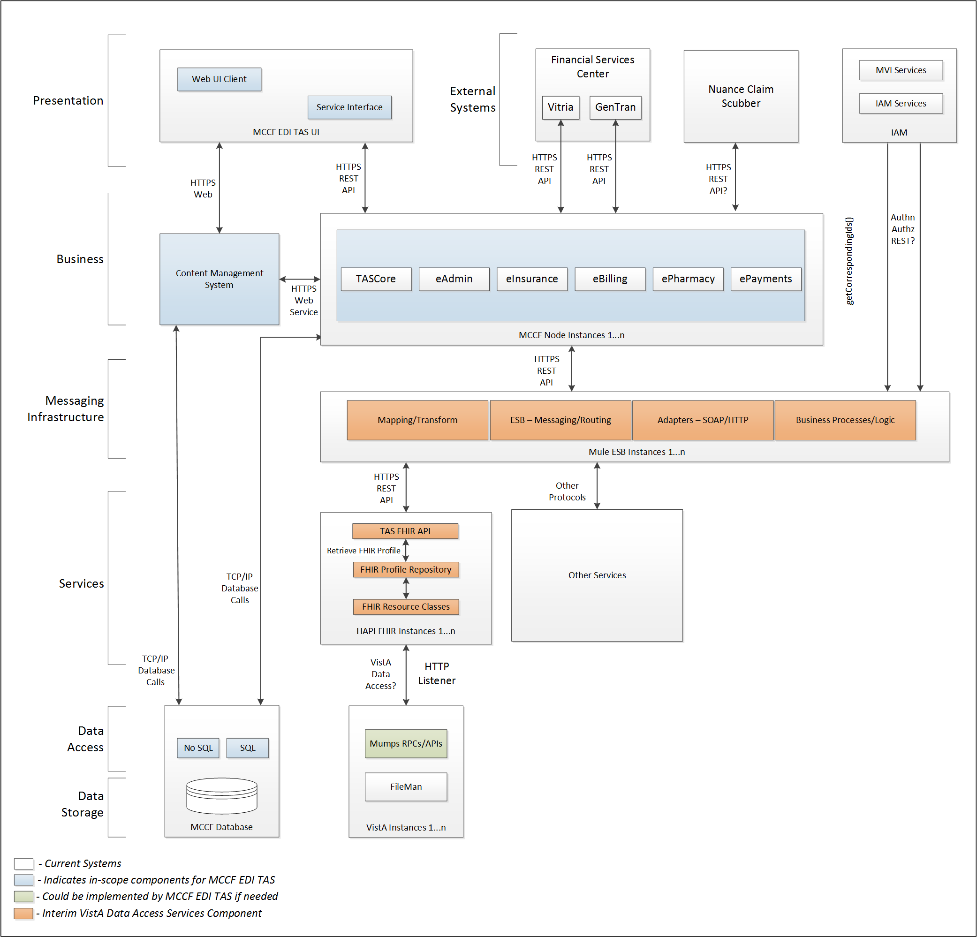

Figure 1 - Interim Solution

To be solution

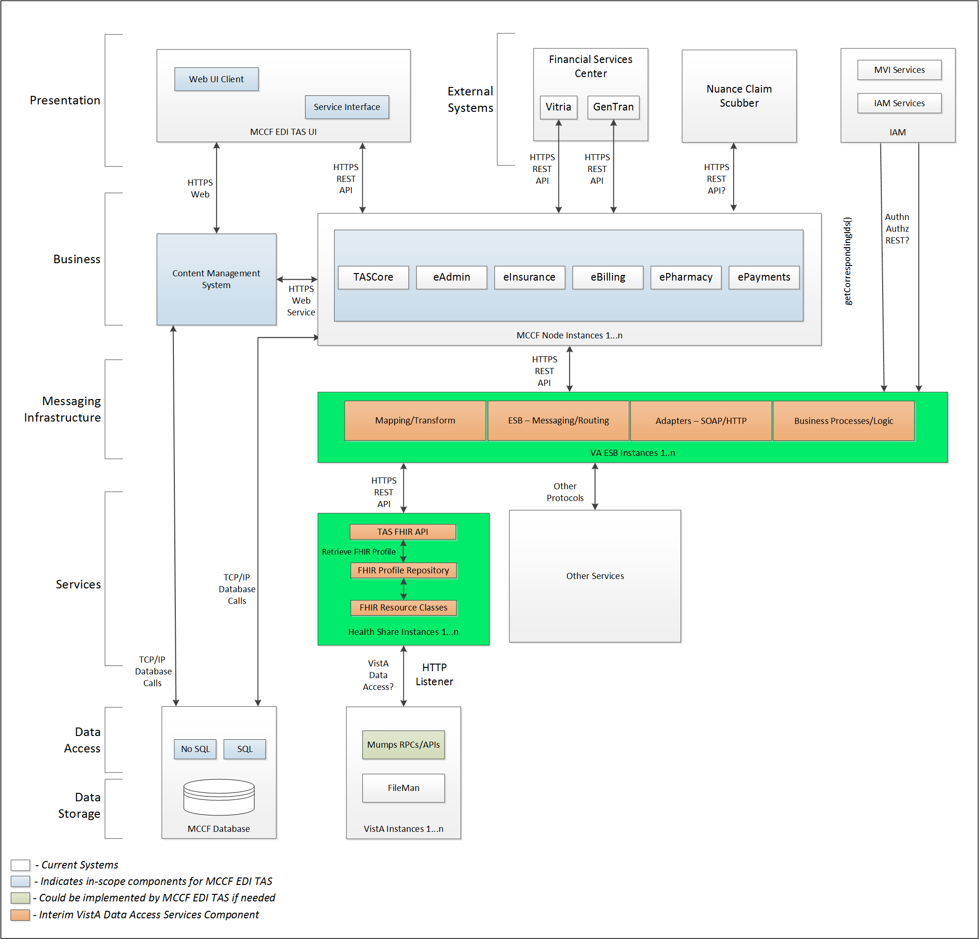

Figure 2 - To Be Solution

## Interface Overview

Exchanging messages between FSC and MCCF EDI TAS eBilling can be done in real time or via message queuing.

### Connectivity between the systems

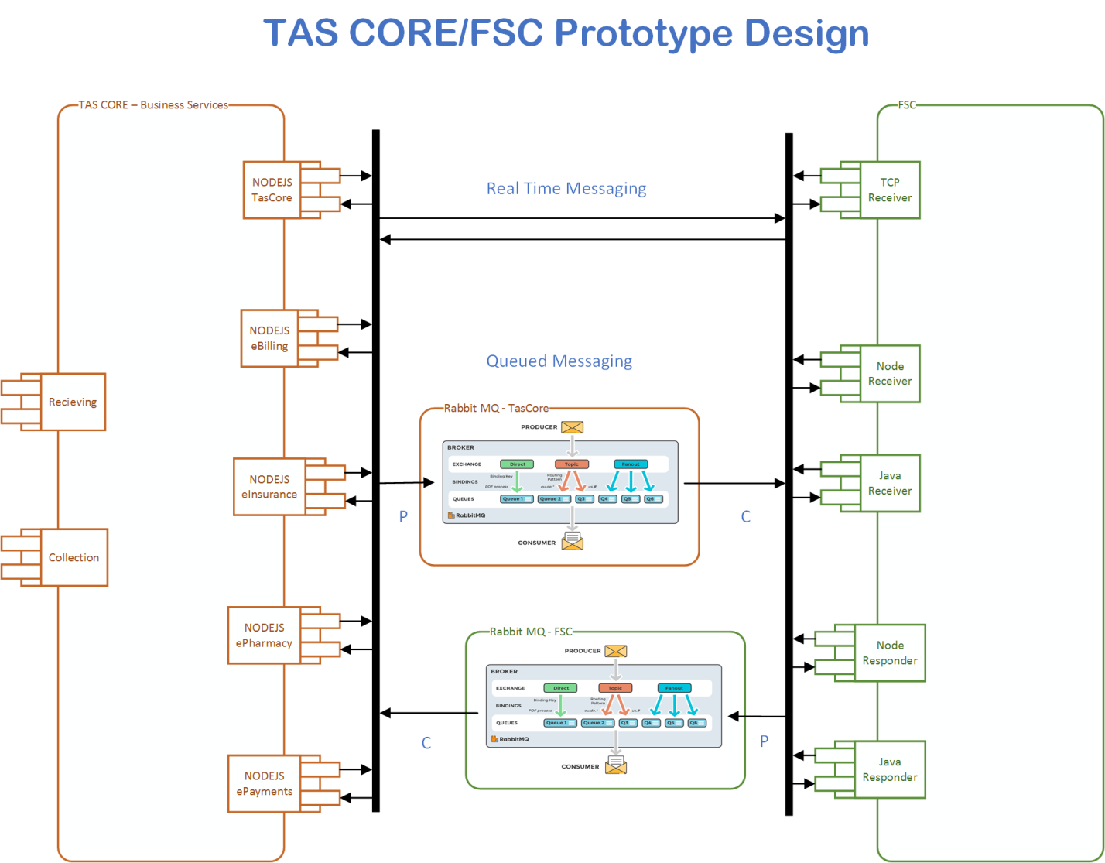

Figure 3 - Connectivity

## Operations

Tbd

### Data Extraction

Tbd

### Data Transformation

Tbd

### Sending/Receiving

MCCF EDI TAS eBilling receives MRA messages from FSC.

## Data Transfer

Data is transferred between the FSC and the TASCore Application Stack.

## Transaction Types

FSC receives MRA messages from HCCH and transmits that data in FHIR resources inside FHIR bundles to MCCF EDI TAS eBilling.

## Data Exchanges

FSC sends a FHIR Bundle to MCCF EDI TAS eBilling.

Refer to Appendix A.

### FHIR Based Resources

#### MRA

The following FHIR resources are needed to assemble an MRA Message FHIR bundle

* Basic
* Claim
* ClaimResponse
* Coverage
* MessageDefinition
* MessageHeader
* Observation
* Organization
* Patient
* PaymentReconciliation
* Practitioner
* Procedure

#### JSON Format

Messages are formatted using the JSON format and implement a Bundle FHIR Resource.

Refer to <https://www.hl7.org/fhir/json.html> for JSON representation of FHIR Resources.

#### 835 MRA FHIR bundle

A bundle implementing an 835 MRA message sent from FSC to MCCF EDI TAS eBilling will have the following structure:

See Appendix A.

### Bundle Definition

A Bundle is a top-level container in FHIR that contains all the FHIR resources desired for a transaction between MCCF EDI TAS and FSC.

A Bundle is a container for resources, enabling one to group and transmit resources altogether at once. Resources such as Claim, Patient, etc., will be transmitted inside multiple entries (see entry list inside Bundle) as a resource type.

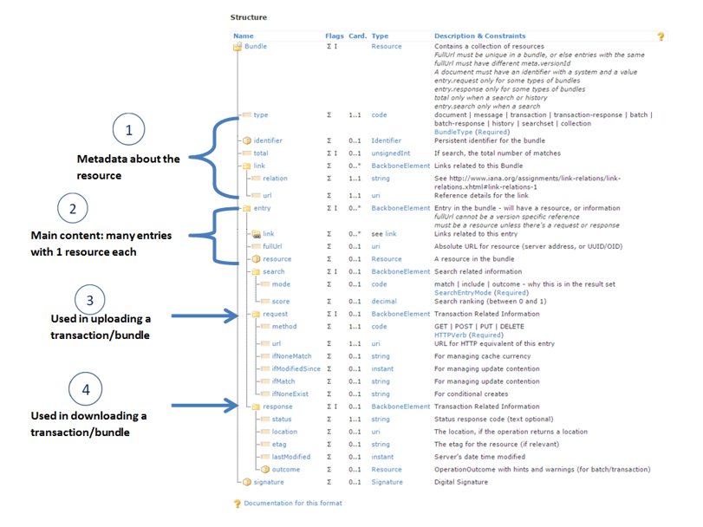

Figure 4 - FHIR Bundle

Source https://fhir-drills.github.io/bundle.html

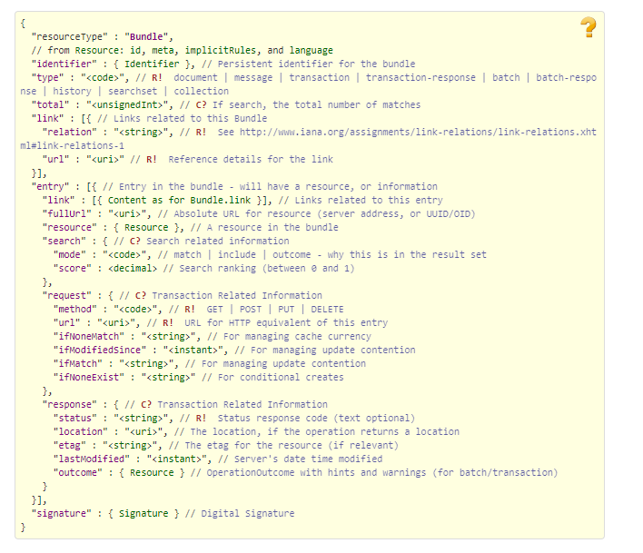

Figure 5 - FHIR Bundle JSON

Source https://www.hl7.org/fhir/bundle.html

## Communications Methods

### Ports and Protocols

#### HTTP(S)

Can be used for real time communication.

#### Advanced Message Queuing Protocol (AMQP)

AMQP offers reliable messaging via queues.

### ESB Configuration(s)

Tbd

### System Configuration

Tbd

## Performance Requirements

Refer to MCCF EDI TAS SDD <https://vaww.oed.portal.va.gov/pm/hape/ipt_5010/EDI_Portfolio/TASCore/MCCF_EDI_TAS_System_Design_Document_v0.7.pdf>

## Security

Refer to MCCF EDI TAS SDD <https://vaww.oed.portal.va.gov/pm/hape/ipt_5010/EDI_Portfolio/TASCore/MCCF_EDI_TAS_System_Design_Document_v0.7.pdf>

## Testing Requirements

1. Connectivity/Secuirity
2. End to End
   1. There might be 2 different End to End test run at different times.
3. Regression testing/Error handling
4. Volume testing
   1. Performance testing
   2. Endurance testing
   3. Load testing
5. Smoke testing

### Comparison of Data

Testing the FHIR conformance will be based on <https://www.hl7.org/fhir/validation.html>.

Business Rules will have to be specifically defined in user stories by the product team.

* Which fields are mandatory from a business perspective?
* Data integrity.
  + There are different approaches that TASCore can employ to test data integrity, depending on future user stories and tasks that will define requirements:
    - Comparing the source data with the output data.
    - Parallel testing: Run data through existing data flow and through the new data flow and make sure data match.
    - Conformance testing (FHIR)
    - Data conformity to business specs
      * Date format
      * Decimal places
      * Currency notations
      * Etc.
* Error handling

### Completeness

Tests defined in section 2.10.1 must cover all the FHIR resources that are defined in section 2.6.1 in consideration of any functional user story.

### Load Testing

Bench mark tests must be performed based on individual use case requirements.

## Policies and Constraints

### HIPAA Compliance

FSC receives MRA data from HCCH.

# Appendix A

## Data Elements

Data being exchanged between TAS and FSC will be formatted in FHIR using the JSON notation. Data elements are mapped into fields in FHIR resources. FHIR resources will be located inside a FHIR bundle.

## Bundle

Repeating fields within a segment need context definition so they can be differentiated within a segment.

Also, repeating fields across multiple segments need to be differentiated. Following steps have been used to assign context to fields.

1. Identify the segment where the resource is located (Bundle.entry.extension.url="segment" and Bundle.entry.extension.valueString=" 835-Header") [MessageType-Segment]
2. Where elements repeat within a segment use extension.valueString to identify field (MessageHeader.extension.url="sequence", MessageHeader.extension.valueString="835-Header-01") [MessageType-Segment-Field]
3. Repeating segments will include an incrementing id (835-PayerAdjustmentRecordGroup2, 835-PayerAdjustmentRecordGroup3, ...)

Following JSON file describes the 835 MRA bundle.

### MRA Bundle



## Resource Sections

### 835 MRA FHIR Bundle Resources

#### Basic

See Basic resource in Bundle included in section 3.2.1

#### Claim

See Claim resource in Bundle included in section 3.2.1

#### ClaimResponse

See ClaimResponse resource in Bundle included in section 3.2.1

#### Coverage

See Coverage resource in Bundle included in section 3.2.1

#### MessageHeader

See MessageHeader resource in Bundle included in section 3.2.1

#### MessageDefinition

See MessageDefinition resource in Bundle included in in section 3.2.1

#### Organization

See Organization resource in Bundle included in section 3.2.1

#### Patient

See Patient resource in Bundle included in section 3.2.1

#### PaymentReconciliation

See PaymentReconciliation in Bundle resource included in section 3.2.1

#### Practitioner

See Practitioner resource in Bundle included in section 3.2.1

#### Procedure

See Procedure resource in Bundle included in section 3.2.1

## Mapping Sheet



# Appendix B - TASCore Mapping Rules

Tbd

# Appendix C – TASCore Default Values

Tbd

# Appendix D – FSC Mapping Rules

Tbd

# Appendix E – FSC Default Values

See mapping sheet section 3.3.4

# Glossary

| **Term** | **Meaning** |
| --- | --- |
| AMQP - Advanced Message Queuing Protocol | The *Advanced Message Queuing Protocol* (*AMQP*) is an open standard for passing business messages between applications or organizations using queues. |
| HCCH | Health Care Clearing House |
| REST - REpresentational State Transfer | REpresentational State Transfer, or RESTful web services provide interoperability between computer systems on the Internet or other network. Sometimes spelled ReST. |

# Attachment A – Approval Signatures

This section is used to document the approval of the ICD. The review should be conducted face to face where signatures can be obtained ‘live’ during the review. If unable to conduct a face-to-face meeting then it should be held via Lync and concurrence captured during the meeting. The Scribe should add /es/name by each position cited.

By signing below, I agree that I have reviewed and agree the document is approved.

